Following on from the bulletin on 4th February regarding Human Trafficking in the press, we would like to advise on an important requirement from BWH Hotels which is relevant to all hotels and all hotel employees.

Operation Makesafe
Operation Makesafe, developed in conjuction with the British Police Force, aims to raise awareness of child exploitation within the business community, including hotels, licensed premises, taxi companies, shops, and care homes.
Initially focused on child sexual exploitation (CSE), Operation Makesafe now addresses all forms of child exploitation, including criminal exploitation (CCE). The campaign’s primary goal is to empower businesses and organisations through increased awareness and training. On this link you can find campaign posters and a training video to raise awareness amongst your staff. By participating in Operation Makesafe, BWH hoteliers can play a crucial role in identifying and protecting potential victims of child exploitation, ensuring timely intervention and safeguarding young people from harm.

Requirement
All staff at international BWH Hotels properties must complete human trafficking training by 30th June 2025. This includes every employee within each property, and you must also ensure any new employees complete the training within 30 days of employment.
The training is available for this is for all employees to complete through the Member Portal, we appreciate not every employee will have a Portal login so we would recommend that the General Manager logs in and shows the content to individuals or a group, at the end of the training the General Manager must authorise that all employees have successfully completed the modules and record this for future reference and review.
Completion and approval by the General Manager will also form part of the QA and evidence will be requested at the time of the QA visit.

Training Access
Login to the Member Portal and select BWH OWL
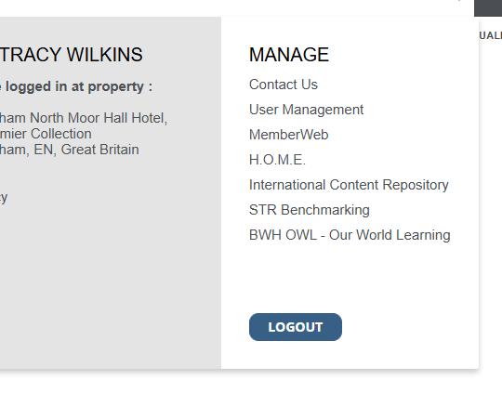
Search for PACT 2025 and select Prevention of Human Trafficking 2025 then select Enrol to complete the training.
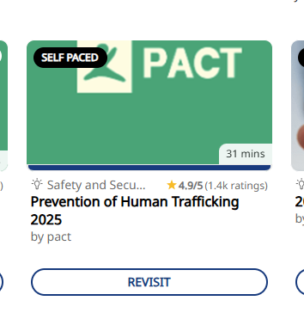

Press Statement:
At present, the media has not been in touch directly, however if you are approached for a comment, please get in touch with me on: Sophie.Proffitt@BWHHotels.co.uk for advice & support.
Should you require any further information or assistance please contact either myself or Matthew Ward.
Many thanks
Tracy Wilkins

